Register to Bid instructions
Click on Auction
Register to Bid
Fill in your information.
Check your email for verification code.
Enter verification code.
Enter payment information.
IMPORTANT: be sure to keep the blue icon selected (cover service fee)
Congratulations, you are registered to bid, you can now view the auction and place your bids.

Step 1: Click on Auction
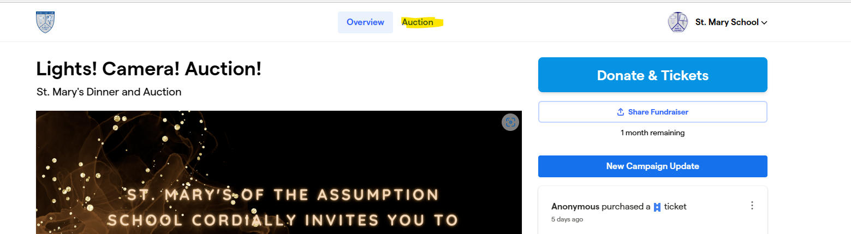
Step 2: Register to Bid
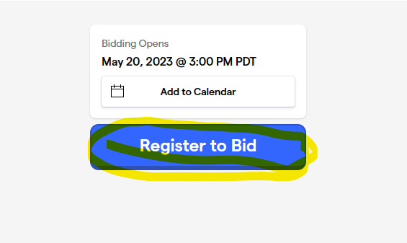
Step 3: Fill in your information.

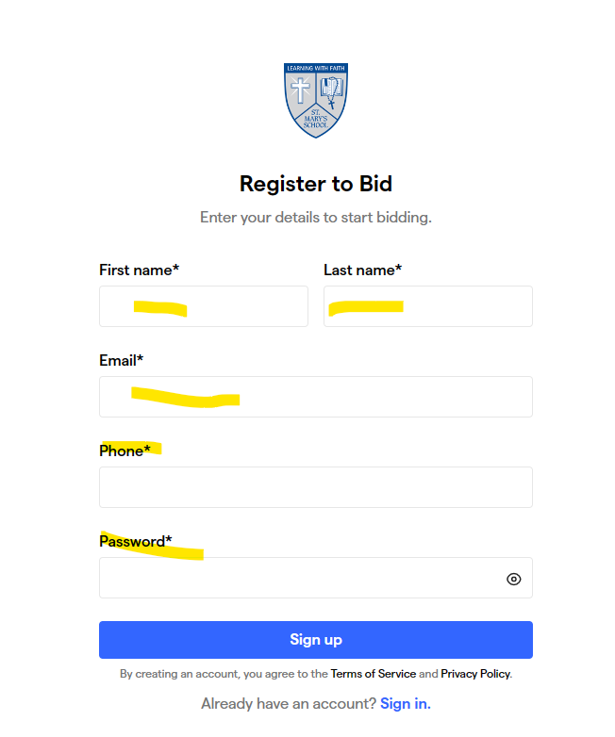
Step 4: Check your email for verification code.
Enter verification code.

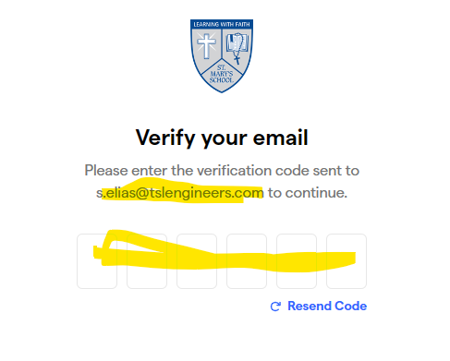
Step 5: Enter payment information, must be filled out, however:
(You do not have to use this method when you check out with the bankers)
You can ask the bankers to pay with cash or check.

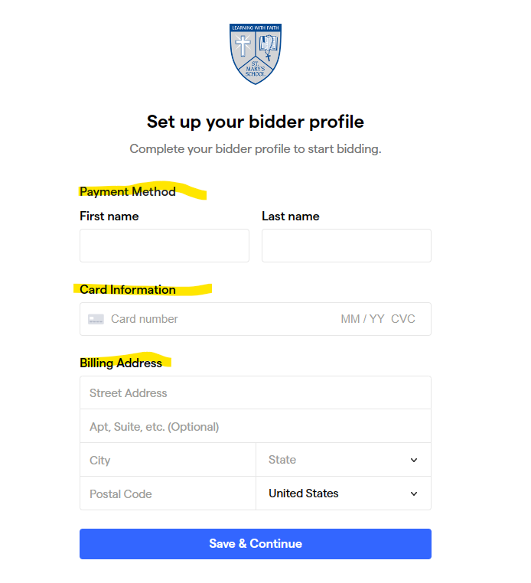
Step 6: IMPORTANT: be sure to keep the blue icon selected (cover service fee)

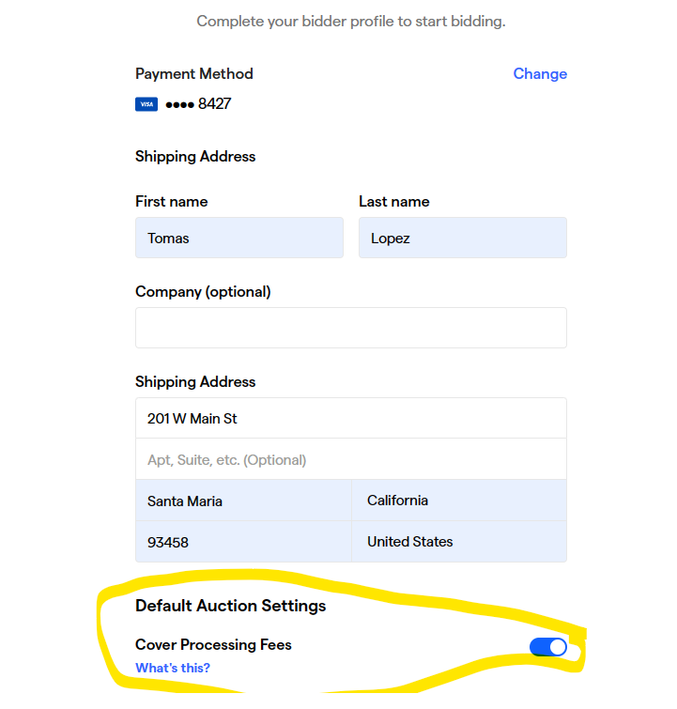
Step 7: Congratulations, you are registered to bid, you can now view the auction and place your bids.

